Delete a Redshift Cluster
Make sure to delete your cluster each time you're finished working to avoid large, unexpected costs. You can always launch a new cluster, so don't leave it running overnight or throughout the week if you don't need to.
- On the Clusters page of your Amazon Redshift console, click on the box next to your cluster to select it, and then click on Cluster > Delete cluster.

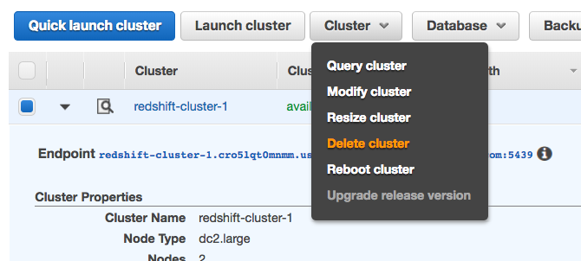

- You can choose No for Create snapshot, check the box that you acknowledge this, and then choose Delete.

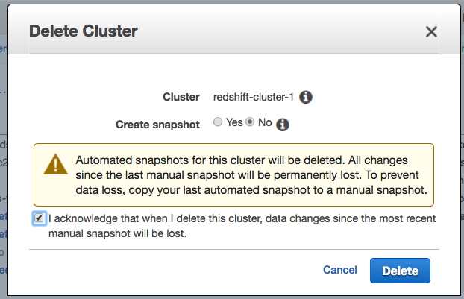

- Your cluster will change it's status to deleting, and then disappear from your Cluster list once it's finished deleting. You'll no longer be charged for this cluster.

